Aws IAM Task-1

- Create one IAM user and assign EC2 and S3 full access roles.
- Create user details > user name Krishna > Select custom password in console password > create user
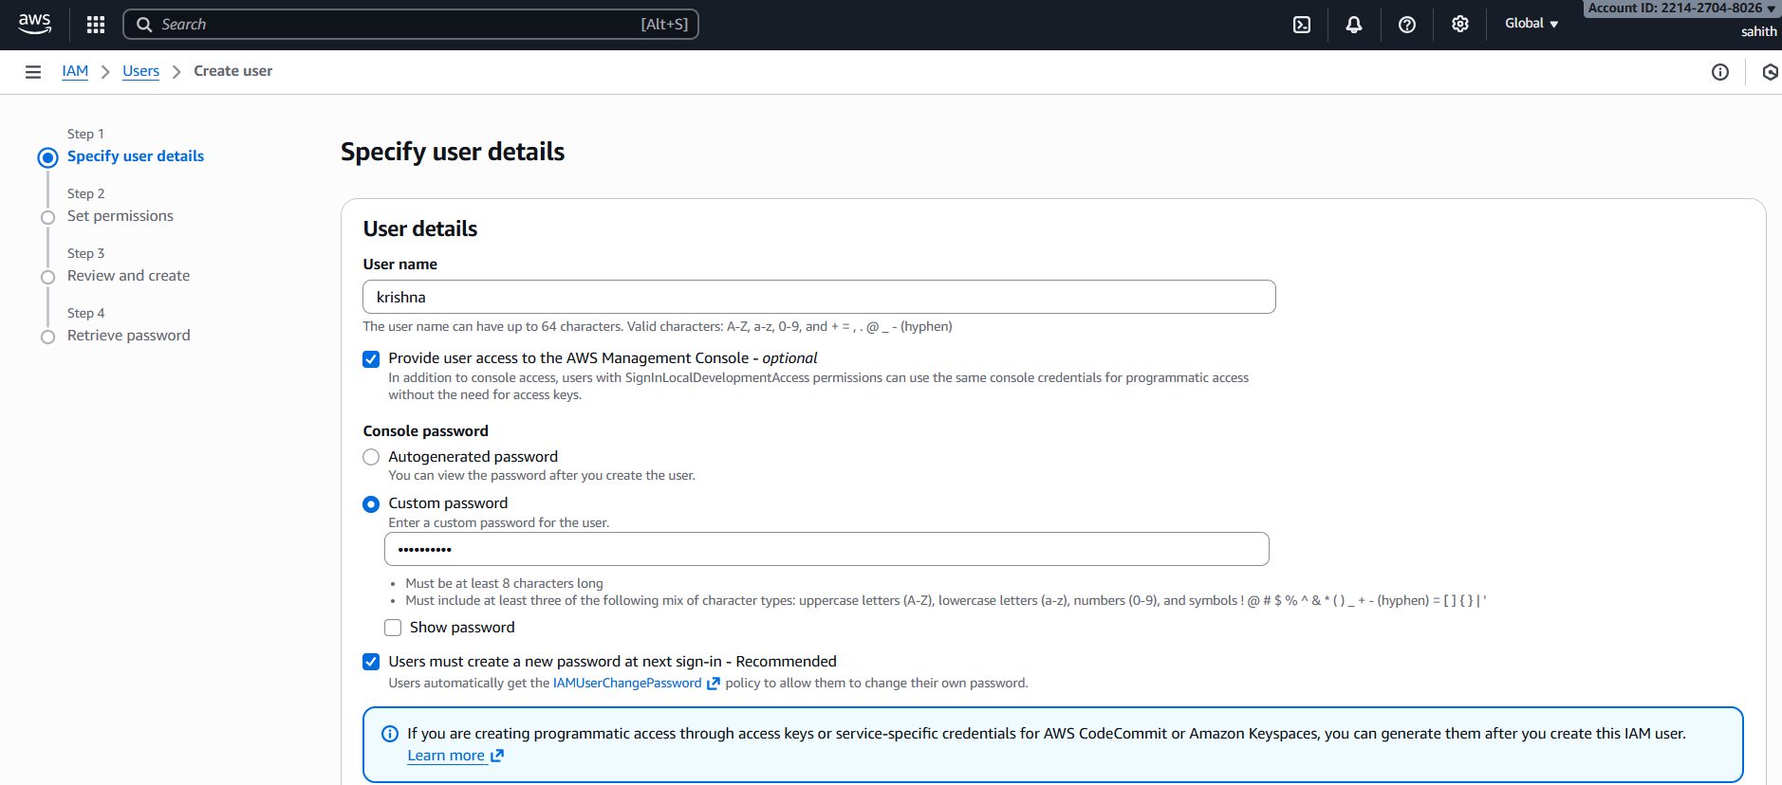
- In set permissions select Attach policies directly > select Amazon s3 full access
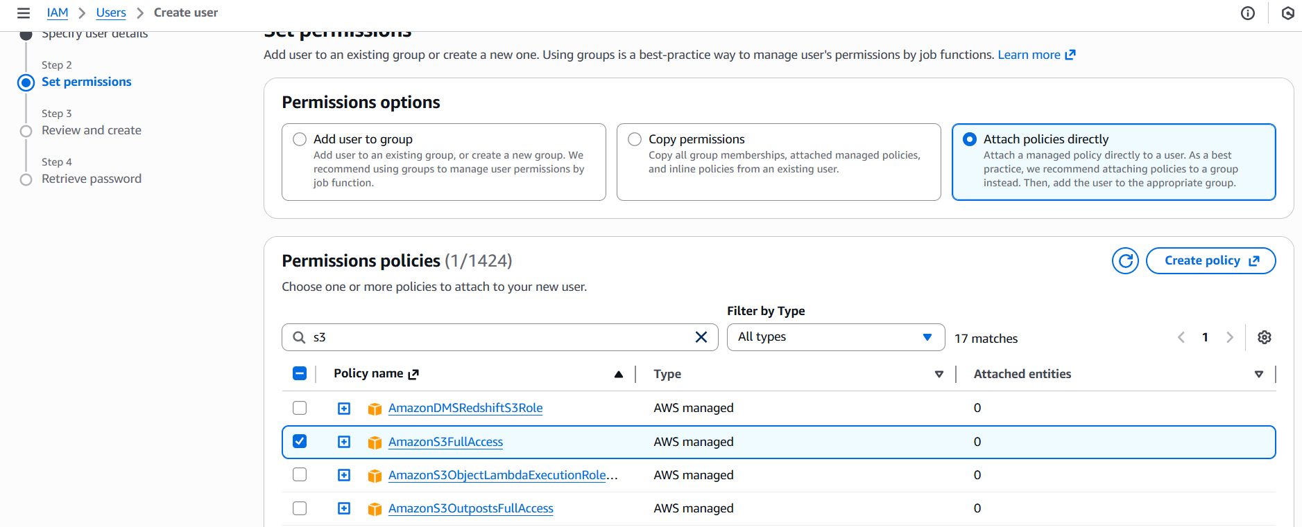
- In set permissions select Attach policies directly > select Amazon ec2 full access
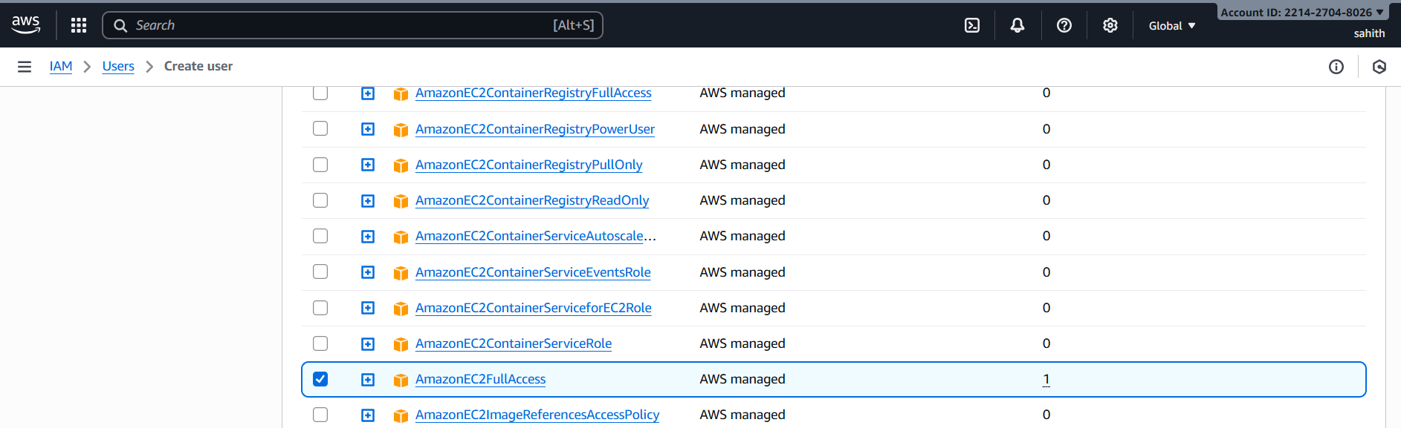
- As we can in below output we have created two permission policy

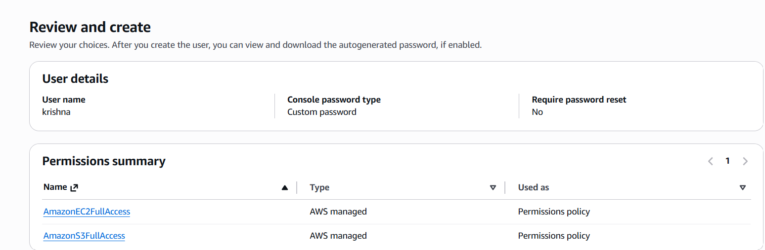
- Next step Retrieve password as we see it provides URL, user name. password
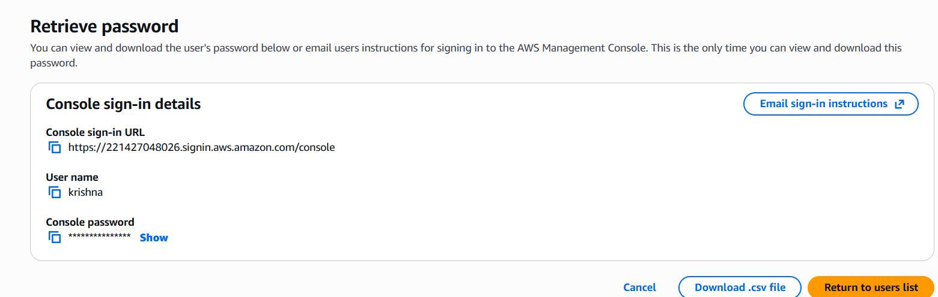
- We have successfully created user krishna
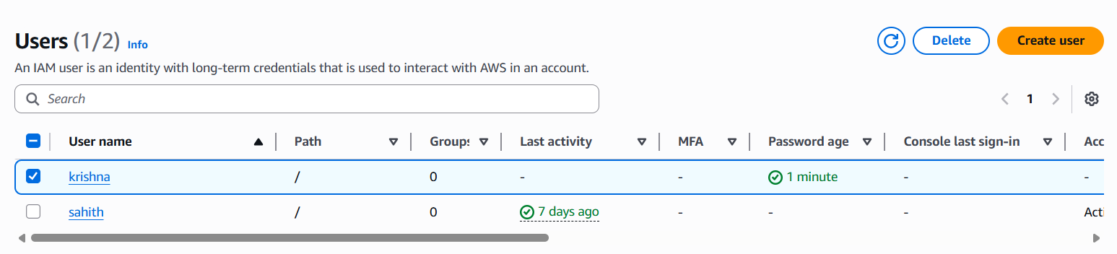
- Validation: sign in with new user which we created before.
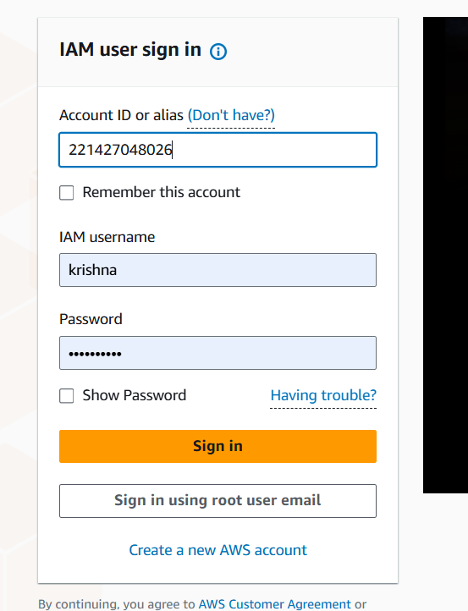
- As we can here logon successfully to new user.
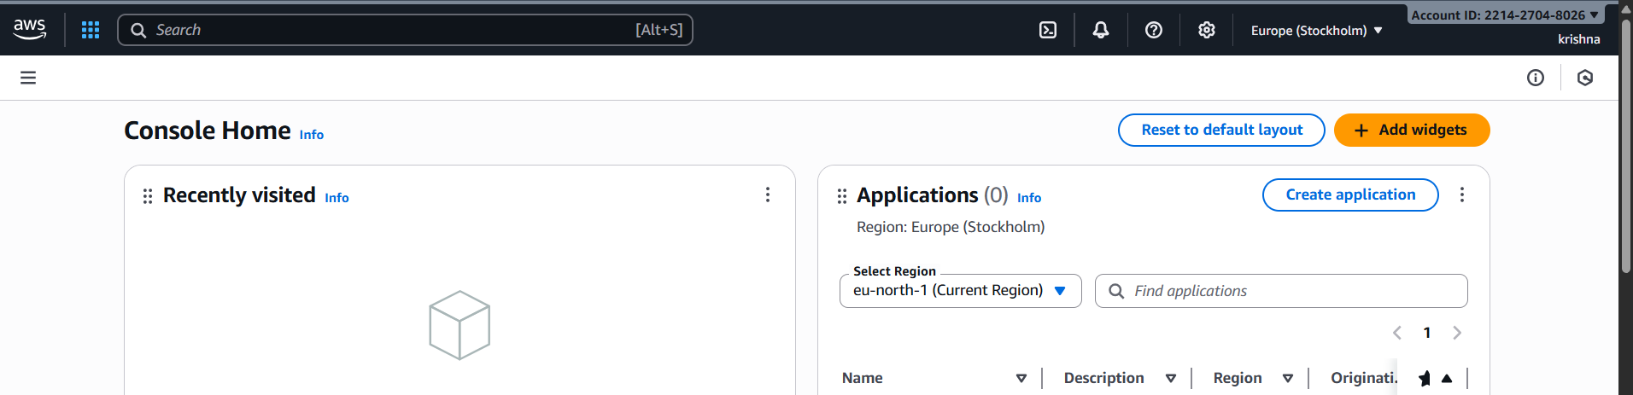
- Create one group in IAM and assign read access for EC2.
- Create user group, gave name opertations
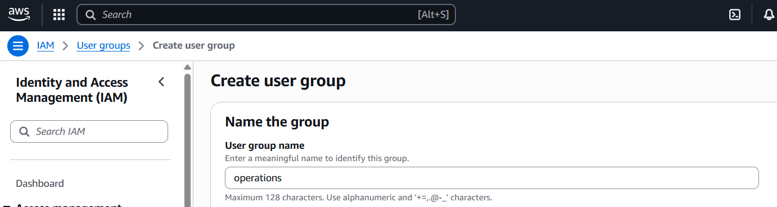
- Selected ec2 read access only
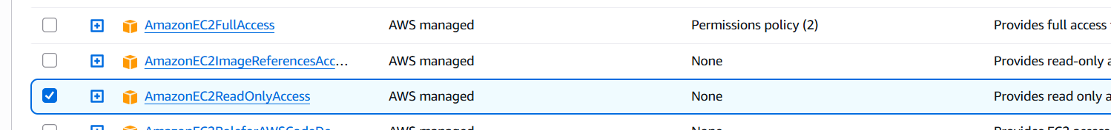
- Successfully created user group operations
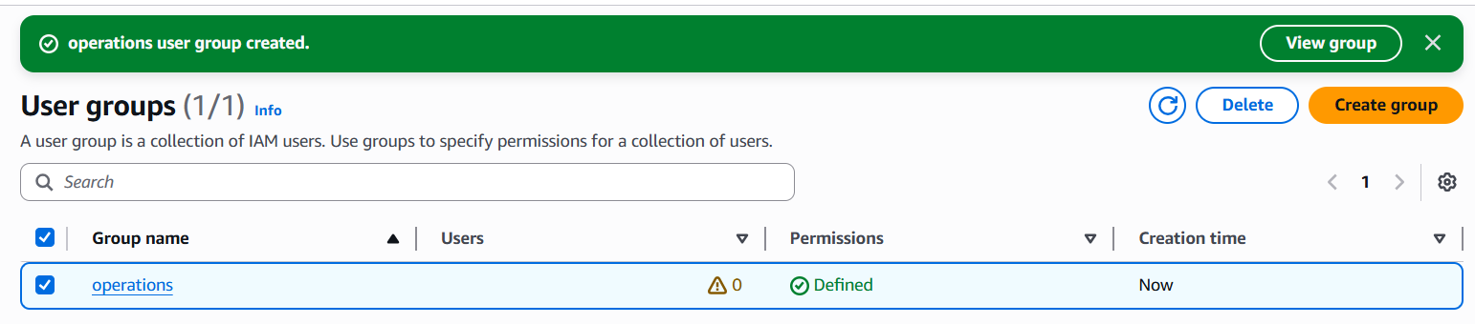
- Create a new user named "Devops" and add to the group created in task 2.
- Created a user Devops
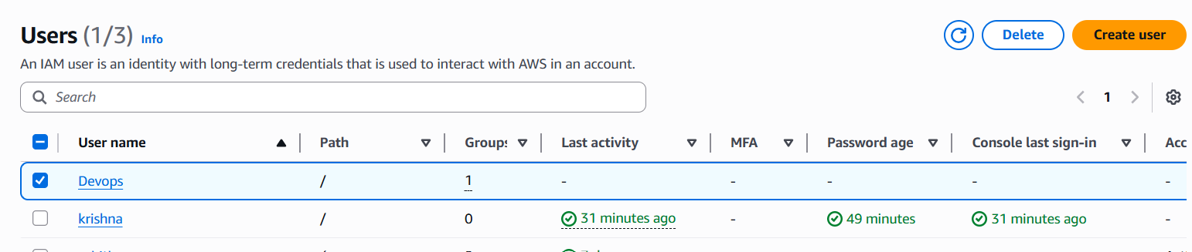
- In set permissions select Add user to group > user groups select operations which we have created in task 2 > select next
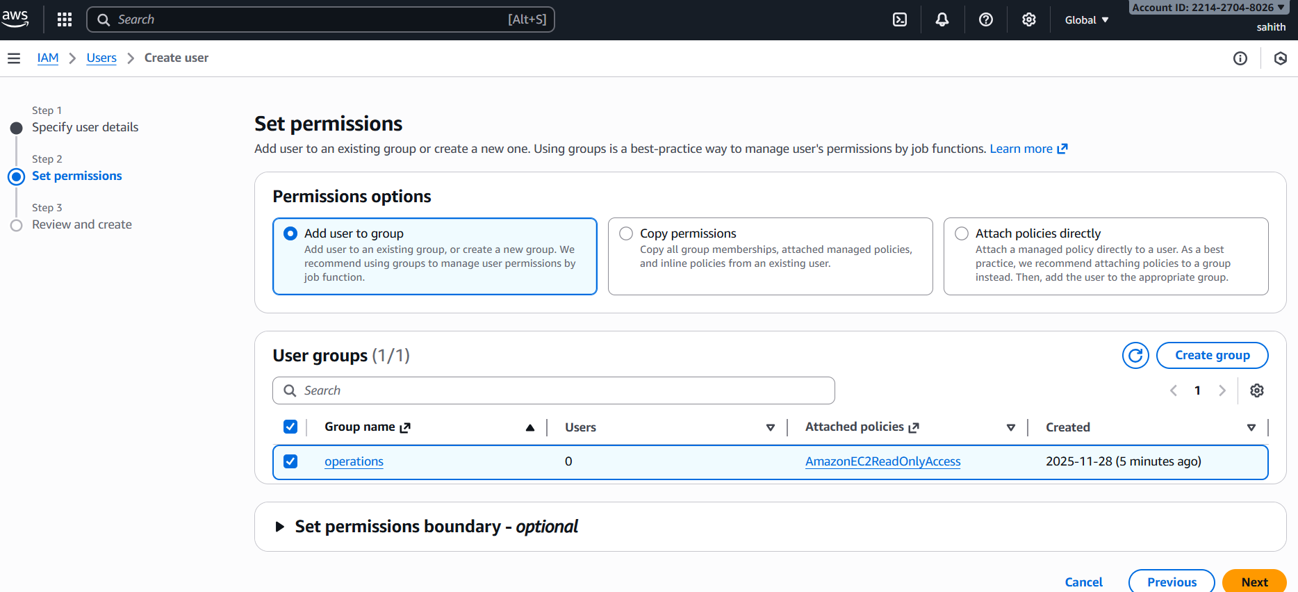
- As we can see below in operations group Devops user is added.
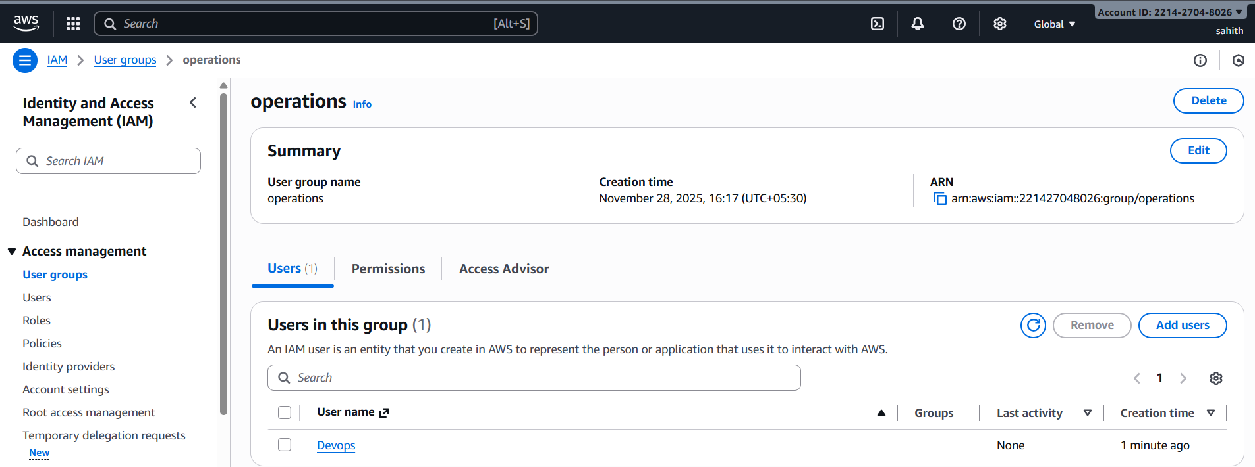

- Write a bash script to create an IAM user with VPC full access.
- Connected to ec2 and gitbash using command Aws configure > enter access key ID > secret access key > region > output format > using vi enter bash script for Iam user with vpc full access. Script is attached below
- Change permissions for web.sh and execute it and it will ask us to enter username (vpcuser) enter.it will be created.
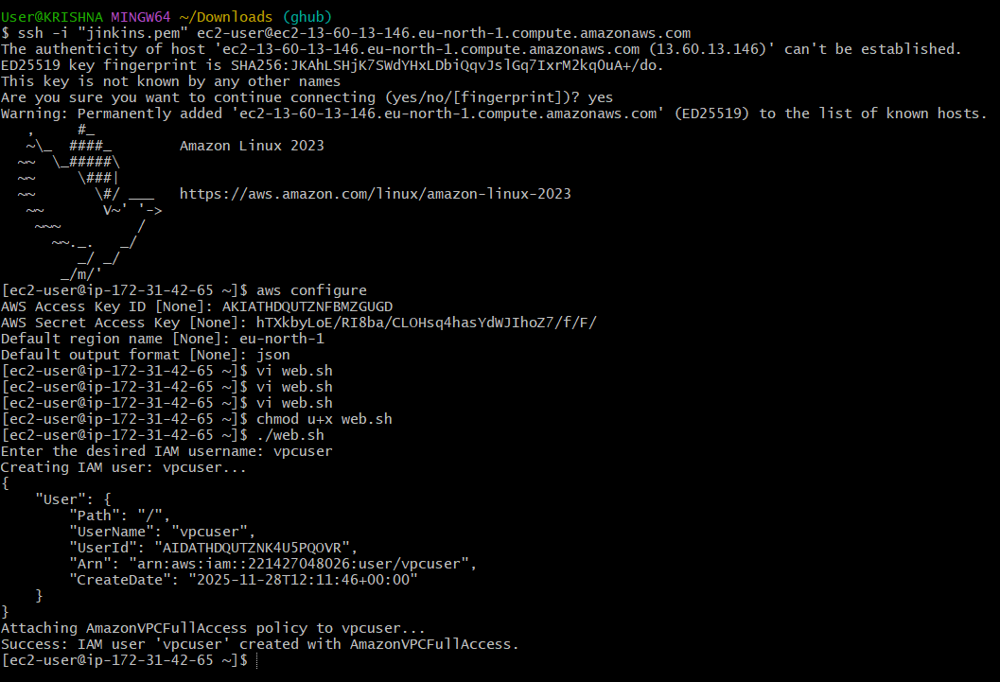
- Bash script to create an IAM user with VPC full access
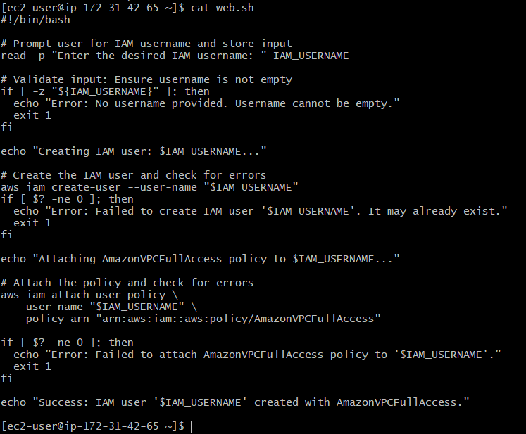
- Validation: We can see below that vpcuser has been created here.
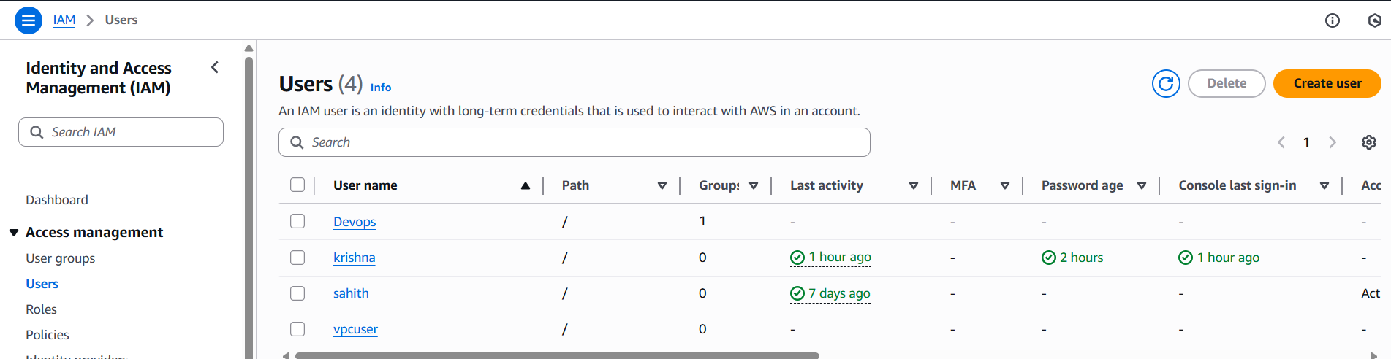
- Create an IAM policy to allow EC2 access for a specific user in specific regions only.
- Create an user in IAM and go to policies > create policies > select Json format on the right side and in policy editor enter the json format code > select create policy below.
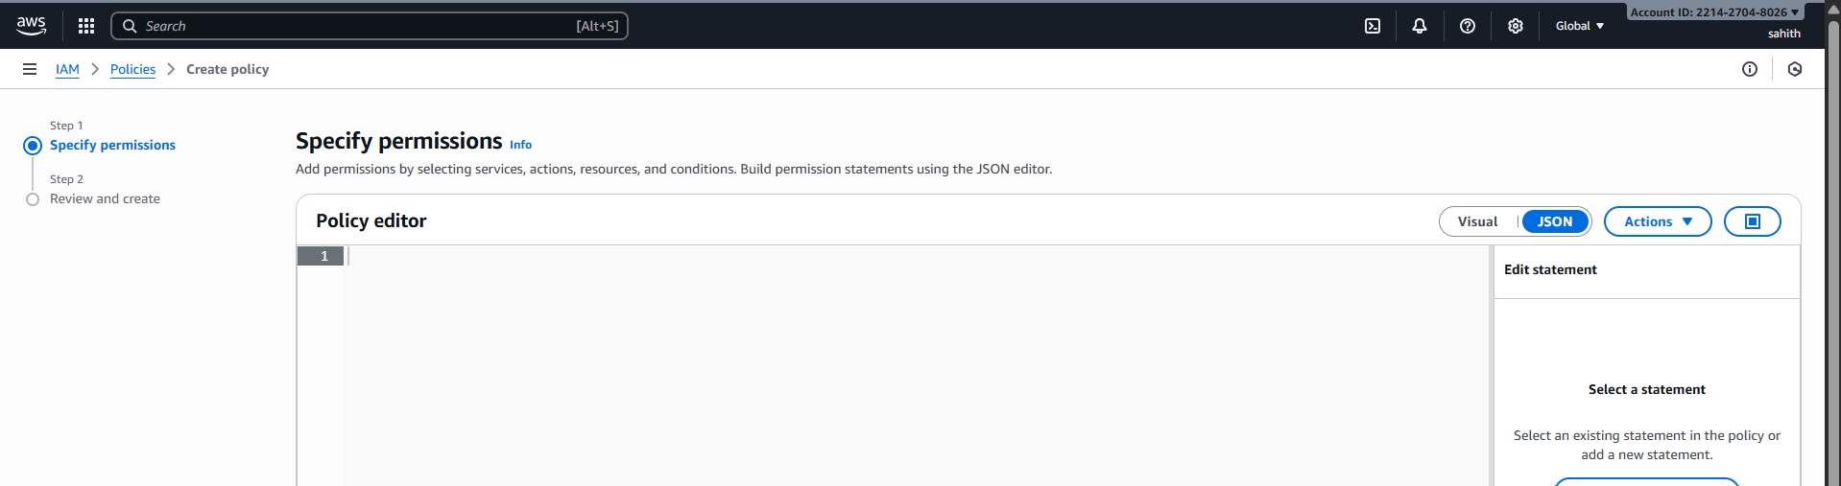
- Here we can see the script for the IAM policy to allow EC2 access for a specific user in specific regions only.
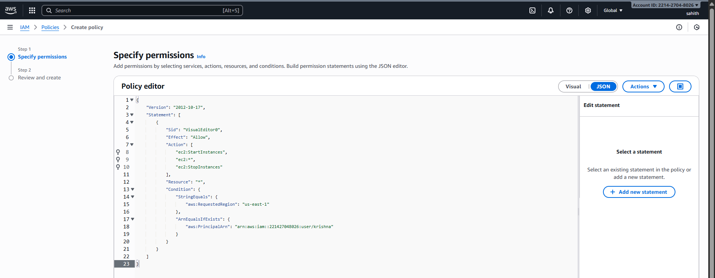
- Give a name to the policy and enter description and click on create policy.
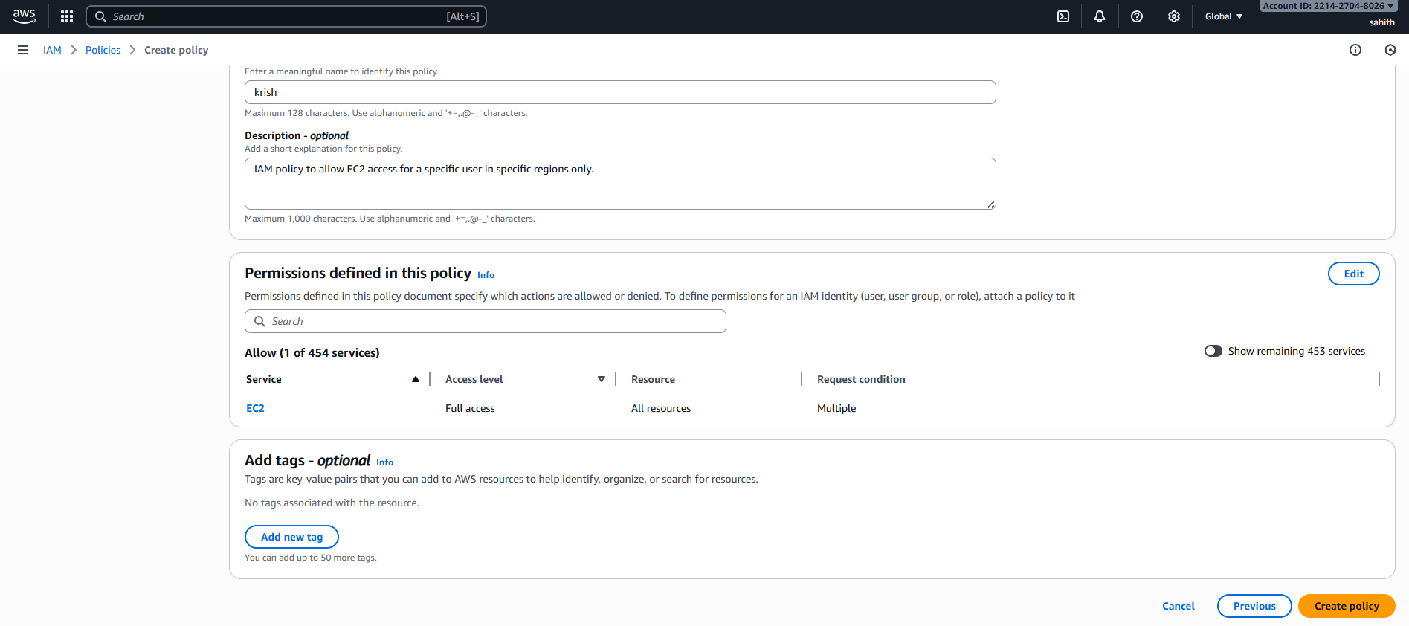
- Validation: as we can see in the below screenshot that policy has been created successfully.
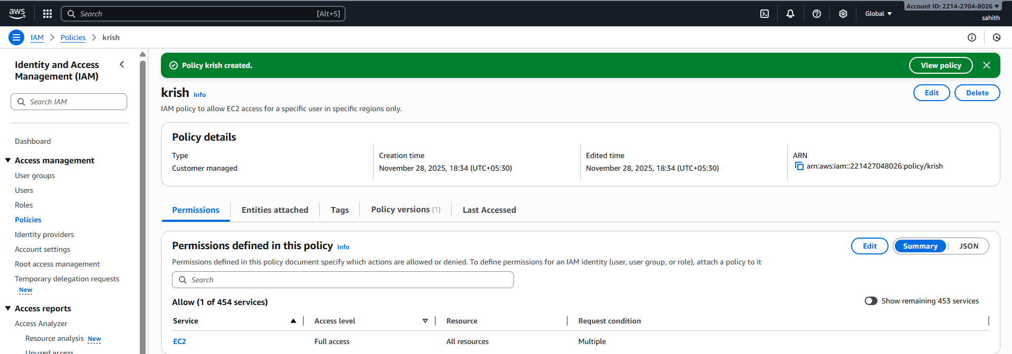

- We have two accounts: Account A and Account B. Account A user should access an S3 bucket in Account B.
- Created an s3 bucket tasks301 and went to permissions and click on edit bucket policy
- Inserted below json format script in account B (it’s my account)
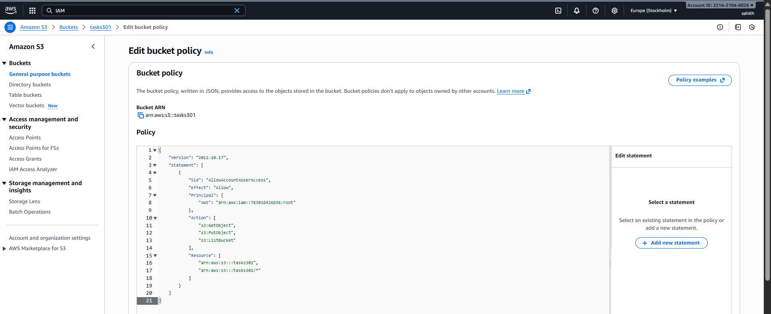
- As we can see below bucket policy has been created with permissions for account A (Sai Teja). We configured and added his account ID and User ID in above script for permissions
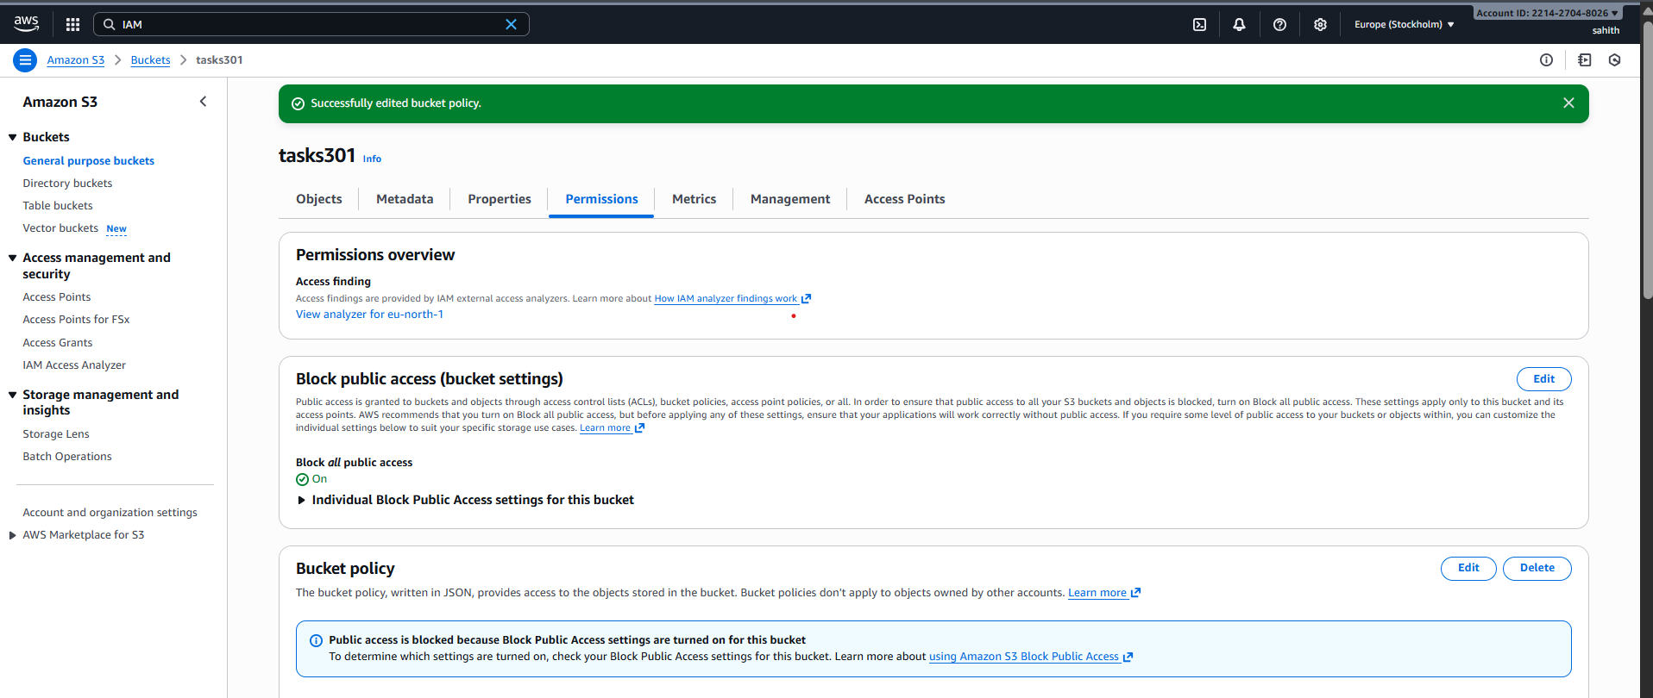
- Validation: from account A, now he can able to access my s3 bucket and objects.
